**Name: Charlie Joseph**

**Date to submitte: 13/04/23**

**Title: Assignment 11 R and Powere BI Projects**

**Tutor: Yusuf**

**Interview Questions:**

**EDA**

1. **Whats is the difference between Univariate, Bivariate, and Multivariate Analysis?**

**Univariate** is when one variable is analyze at a time, it is call univariate data analysis. This analysis aims to describe the variable in questions and find pattersn that exist within it, example: height of patients

**Bivariate** involves two different variables the analysis of this type of data deals with causes and relationsips. The investigation determins the relationship between the two variables, where one of the variables is the target variable, Example temperature and cold drinks sales in the summere seasons.

**Multivariate** is the analyzing of three or more variables together is categorixed under multivariate data analysisl it is similar to a bivariate but contains more than one dependents variable.. example data for flight price prediction.

1. **What is an outlier and how to identify them?**

An outlier in statistics, is a data point that differs significantly from other observations. They can be identified visually using a boxplot. The 1.5 rule can be used to remove outliers.

1. **What is correlation?**

The process of extablishing a relationship or connection between two or more things. The commonly used methods of correlation are pearson, Kendail and spearman or Name, Age and Gender.

**Task in R**

1. Data was downloaded from source: as seen in the screenshot below.



1. Downloaded excel file: as seen in the screenshot below.

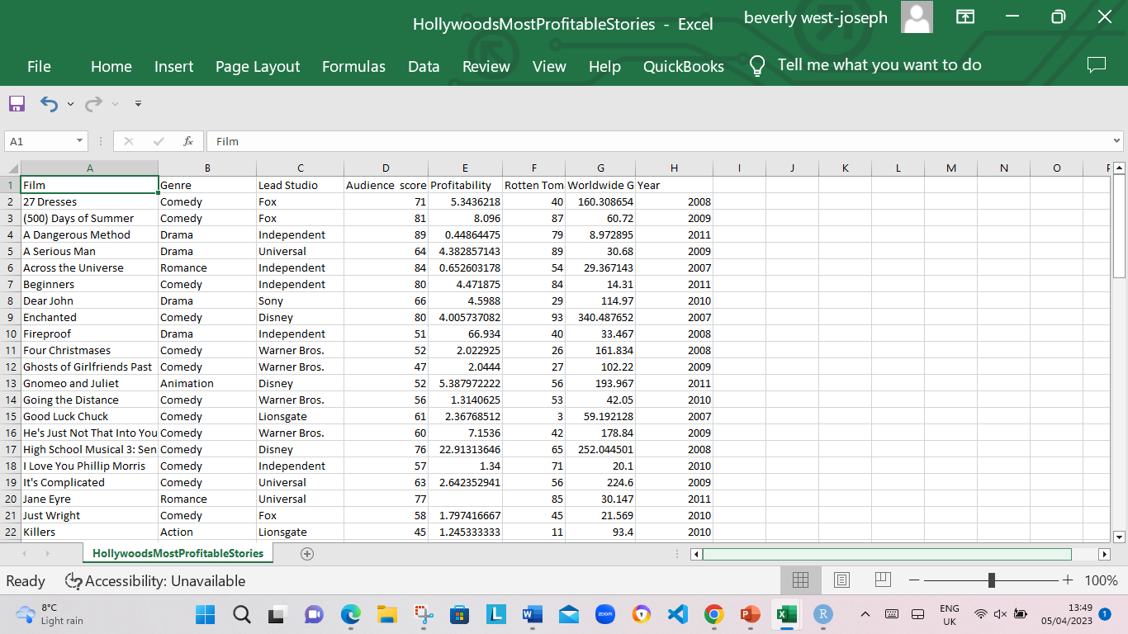

1. The data was loaded/imported into are using the codes line df<- read.csv(“<https://public.tableau.com/app/sample-data/HollywoodsMostProfitableStories.csv>") as seen in the screenshot below.

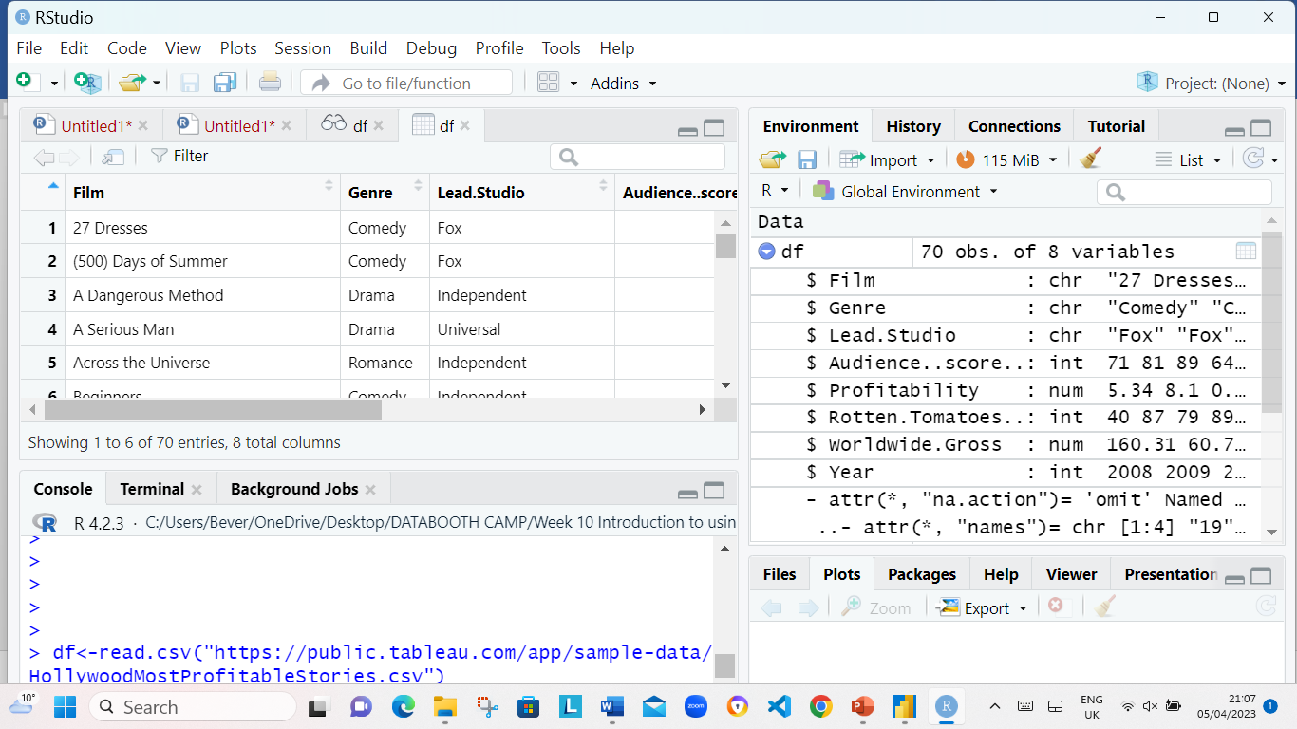

1. The data was looked at by using the following codes: View(df) as seen in the screenshot below.

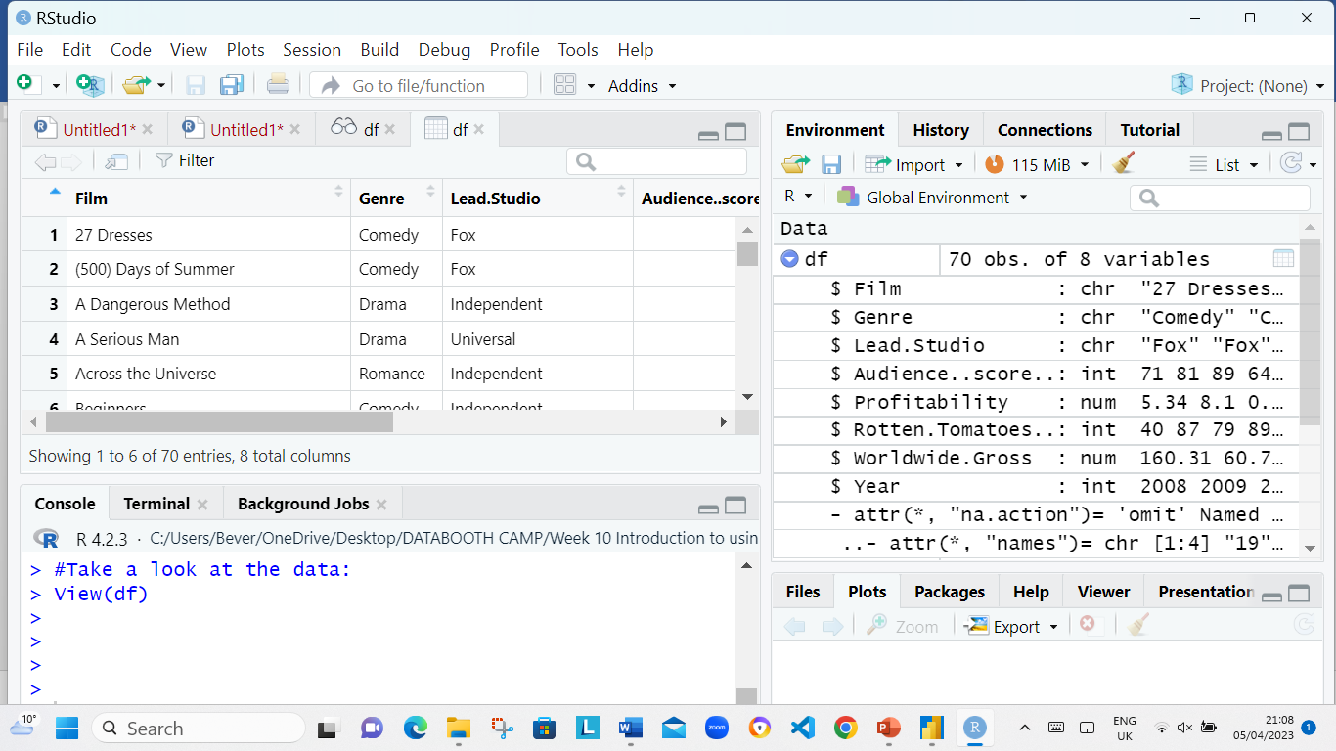

1. The Tidyverse library was installed using the following codes: ​install.packages("tidyverse") ​ was install in R. As in the screenshot below.

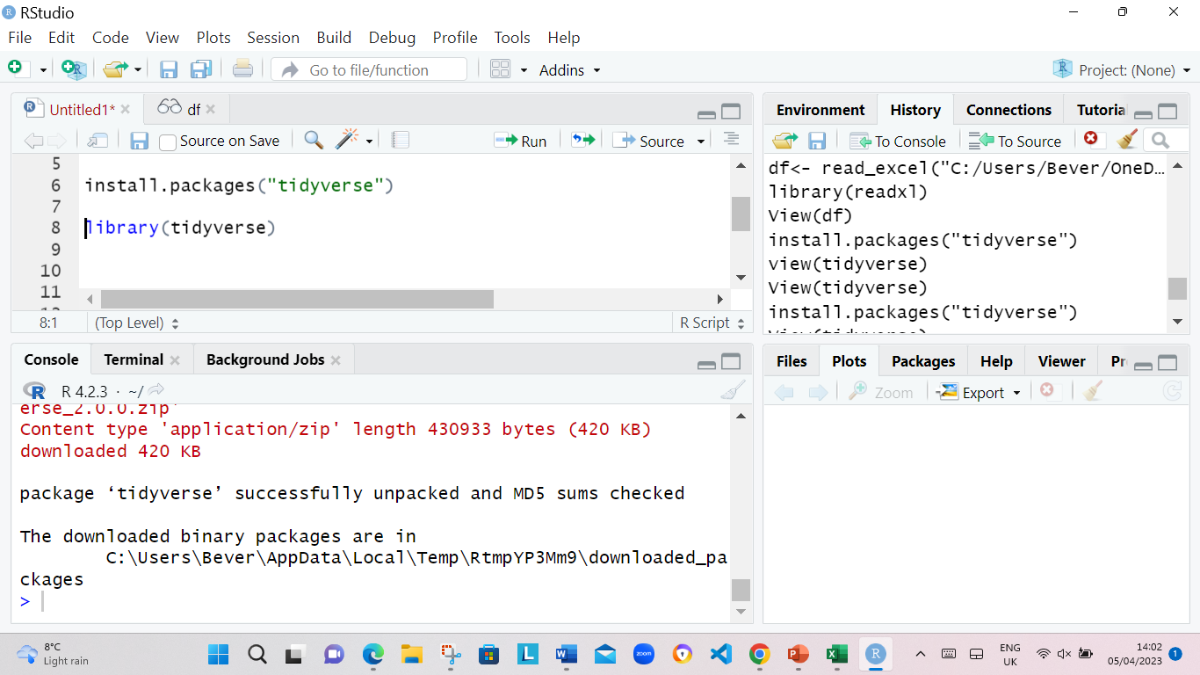

1. The data type was checked using the following codes: ​str(df). The screen shot show the data type.

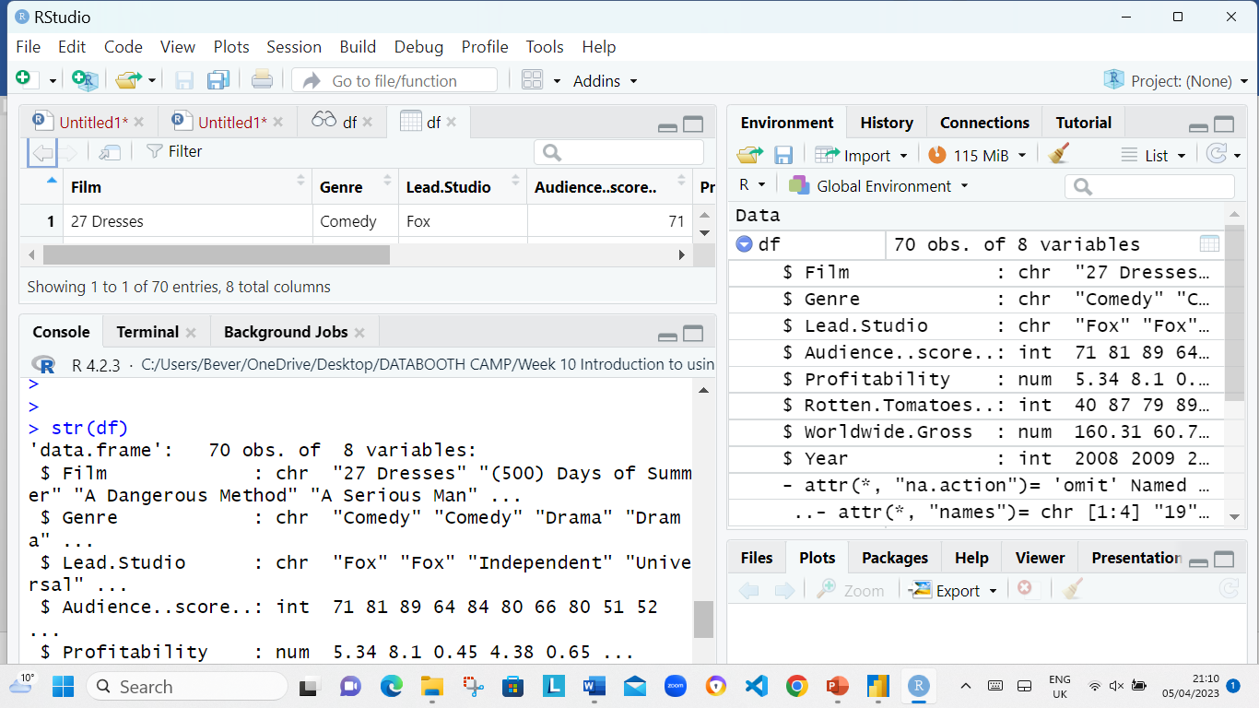

**Step 2: Clean Data**

1. Th following codes was used to Check for missing values: ​colSums(is.na(df) as seen in screenshot below.

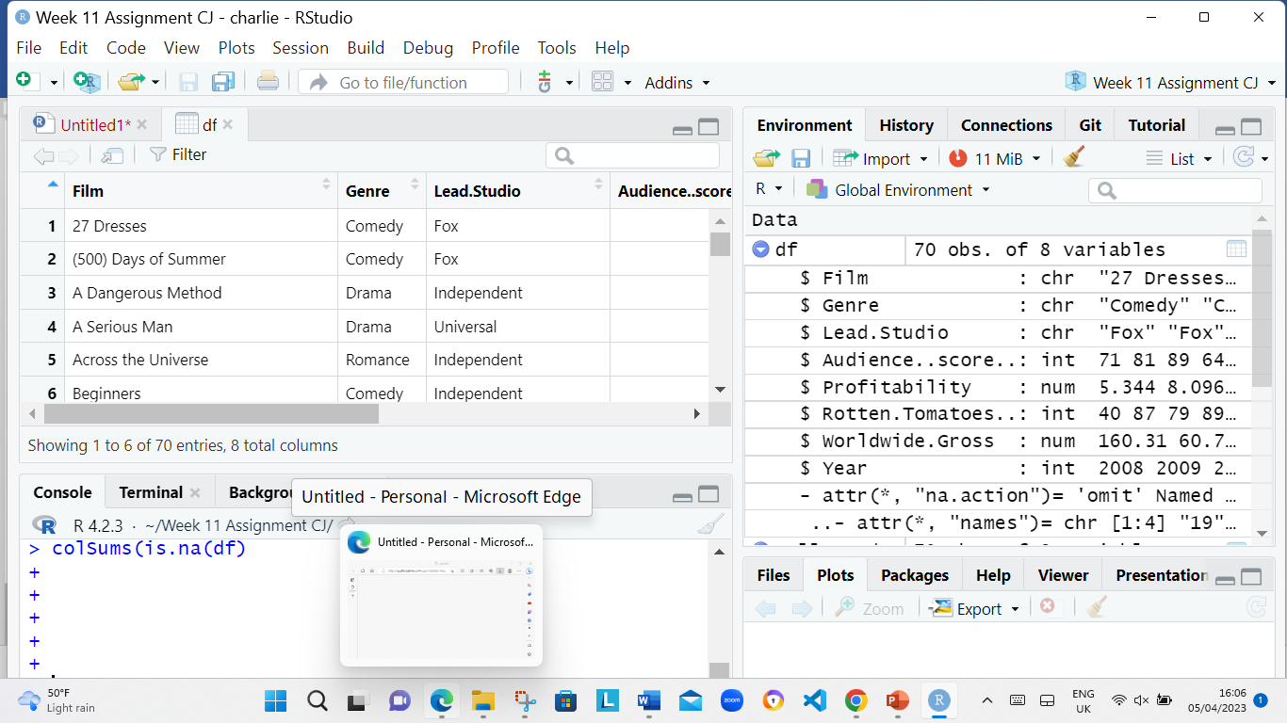

1. Th following codes was used to Drop missing values : df <- na.omit(df) as seen in screenshot below.

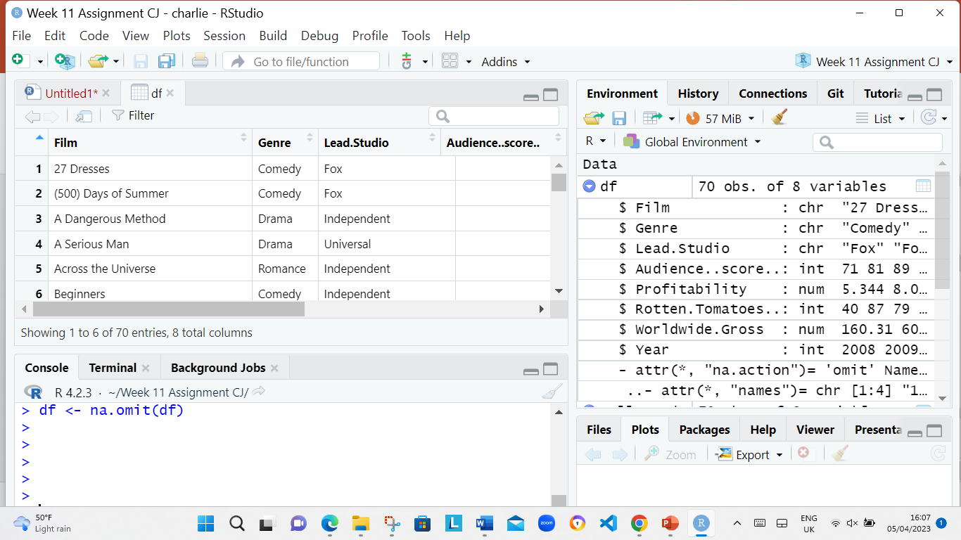

3. The following codes was used to check to make sure that the rows have been removed colSums(is.na(df)) as seen in screenshot below.

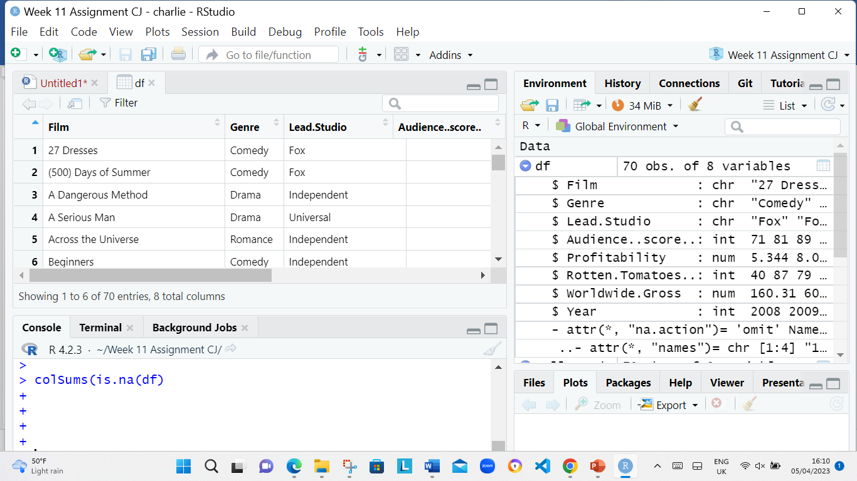

1. The following codes was used to Check for duplicates

dim(df[duplicated(df$Film),])[1] as seen in screenshot below.

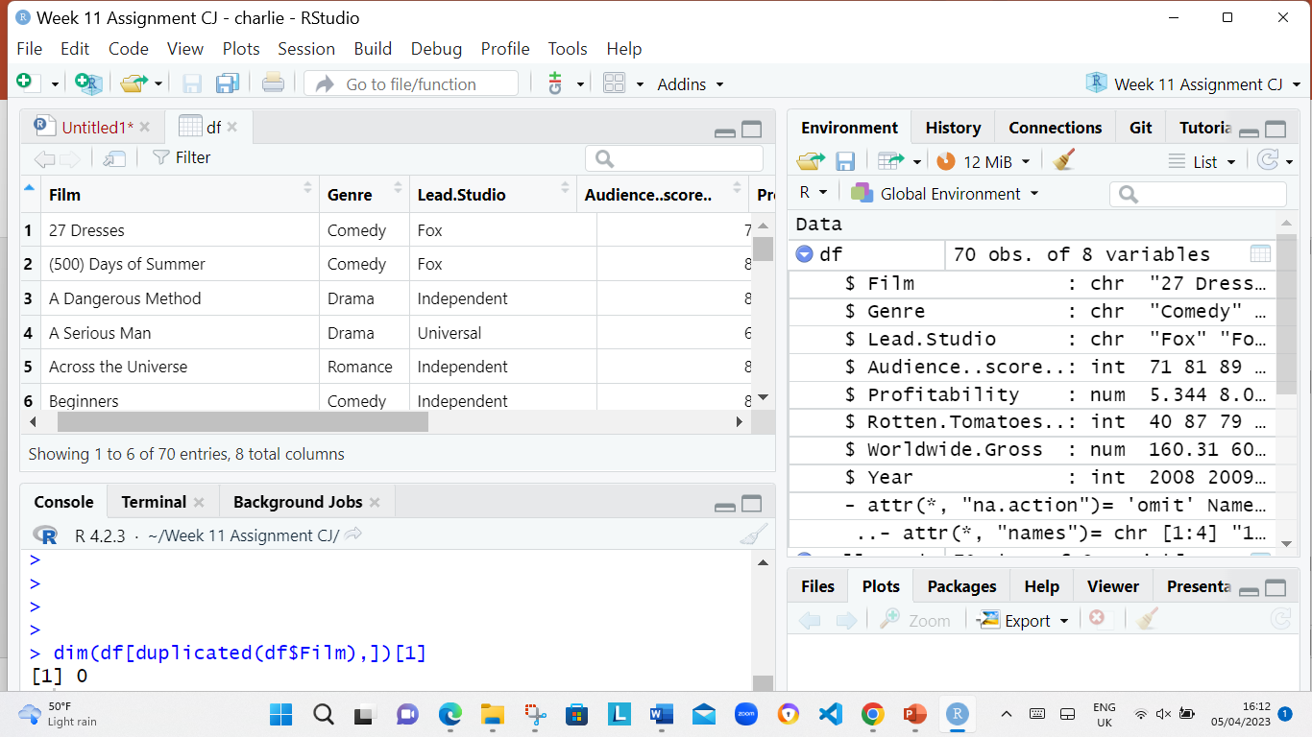

1. The following codes was used to round off values to 2 places

df$Profitability <- round(df$Profitability ,digit=2) as seen in screenshot below.

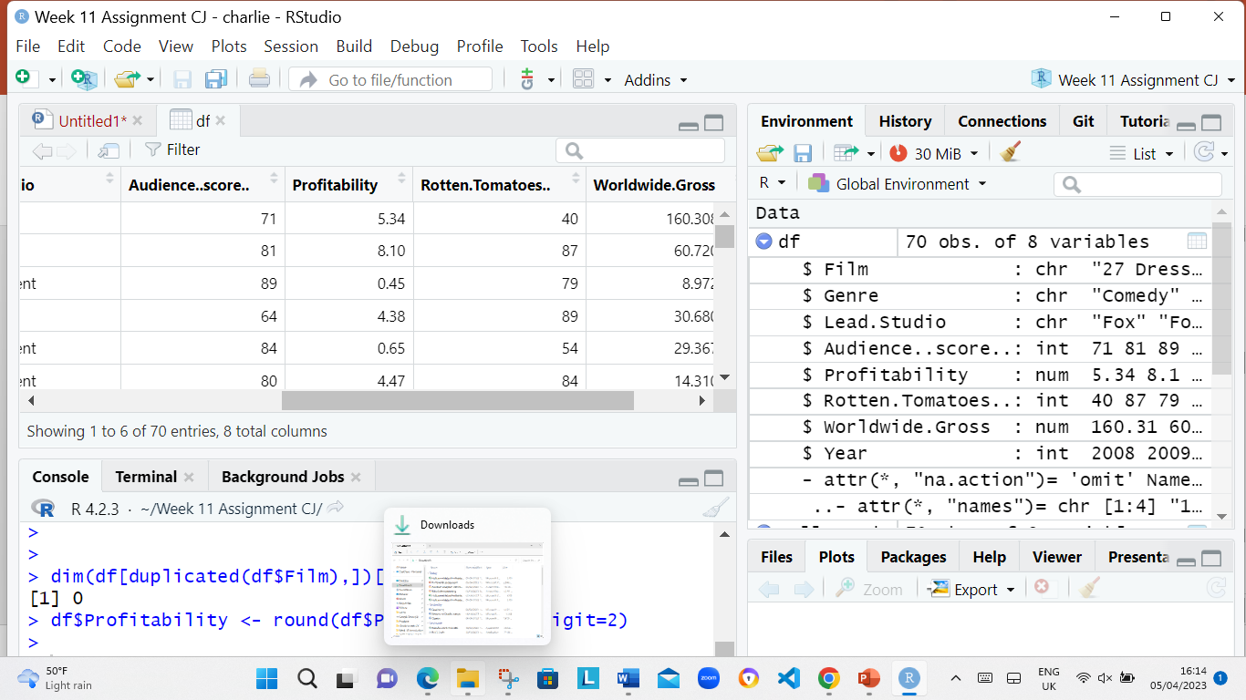

df$Worldwide.Gross <- round(df$Worldwide.Gross ,digit=2)

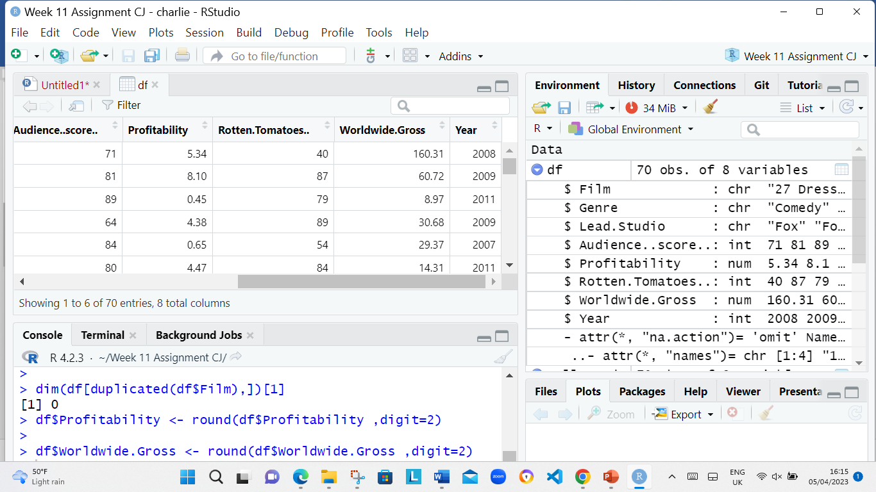

1. The following codes was used

View(df)

dim(df) as seen in screenshot below.

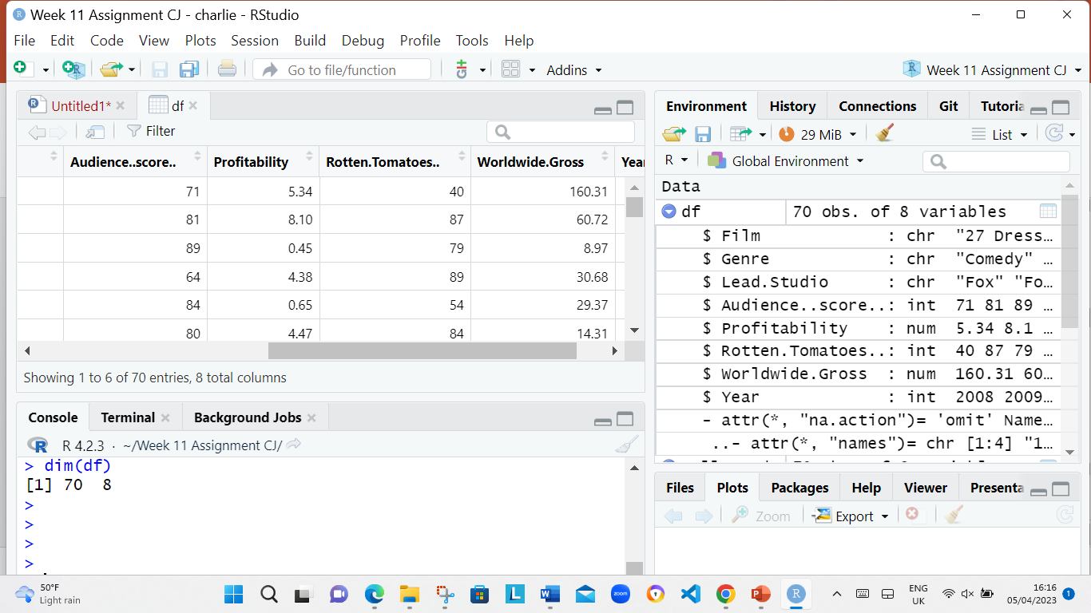

**Step 2.1: Outlier removal**

1. The following codes was used Check for outliers using a boxplot

library(ggplot2)

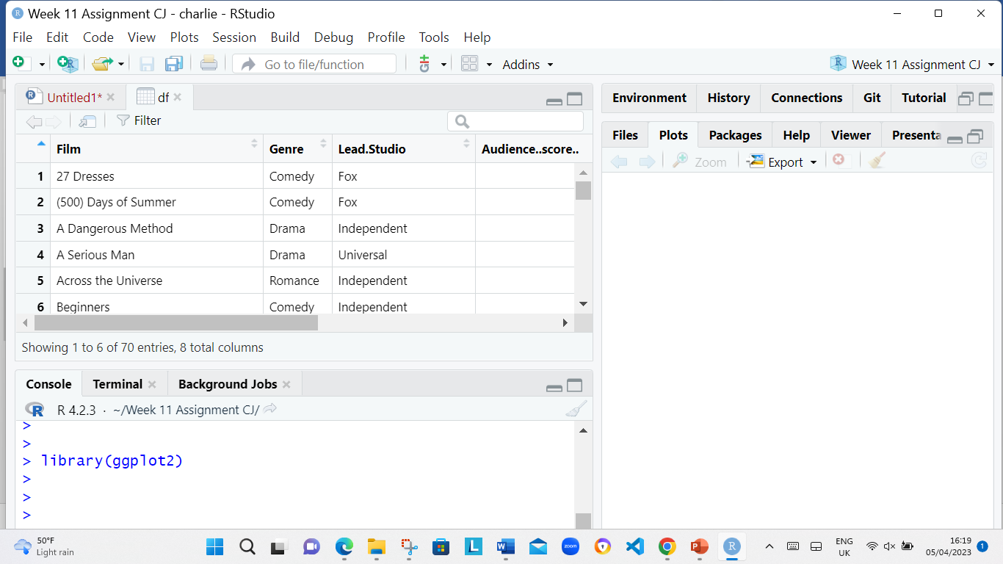

1. The following codes was used to Create a boxplot that highlights the outliers

ggplot(df, aes(x=Profitability, y=Worldwide.Gross)) + geom_boxplot(outlier.colour = "red", outlier.shape = 1)+ scale_x_continuous(labels = scales::comma)+coord_cartesian(ylim = c(0, 1000))

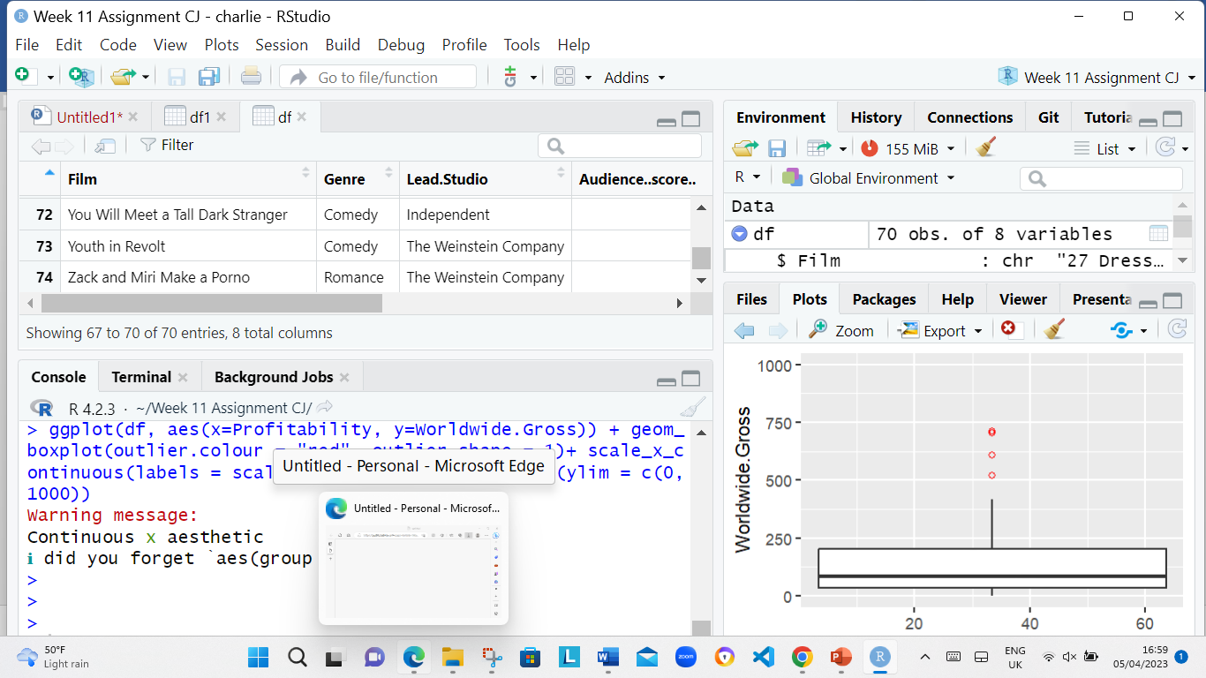

1. The following codes was used to Remove outliers in 'Profitability'

Q1 <- quantile(df$Profitability, .25)

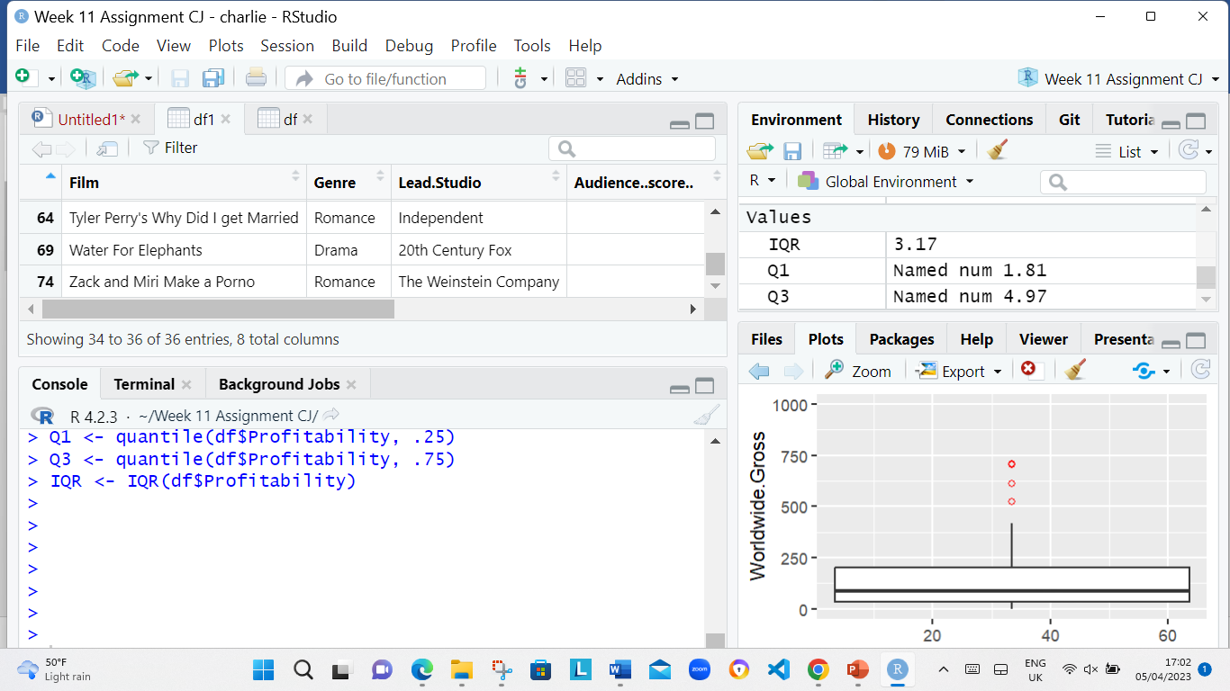

Q3 <- quantile(df$Profitability, .75)



IQR <- IQR(df$Profitability)

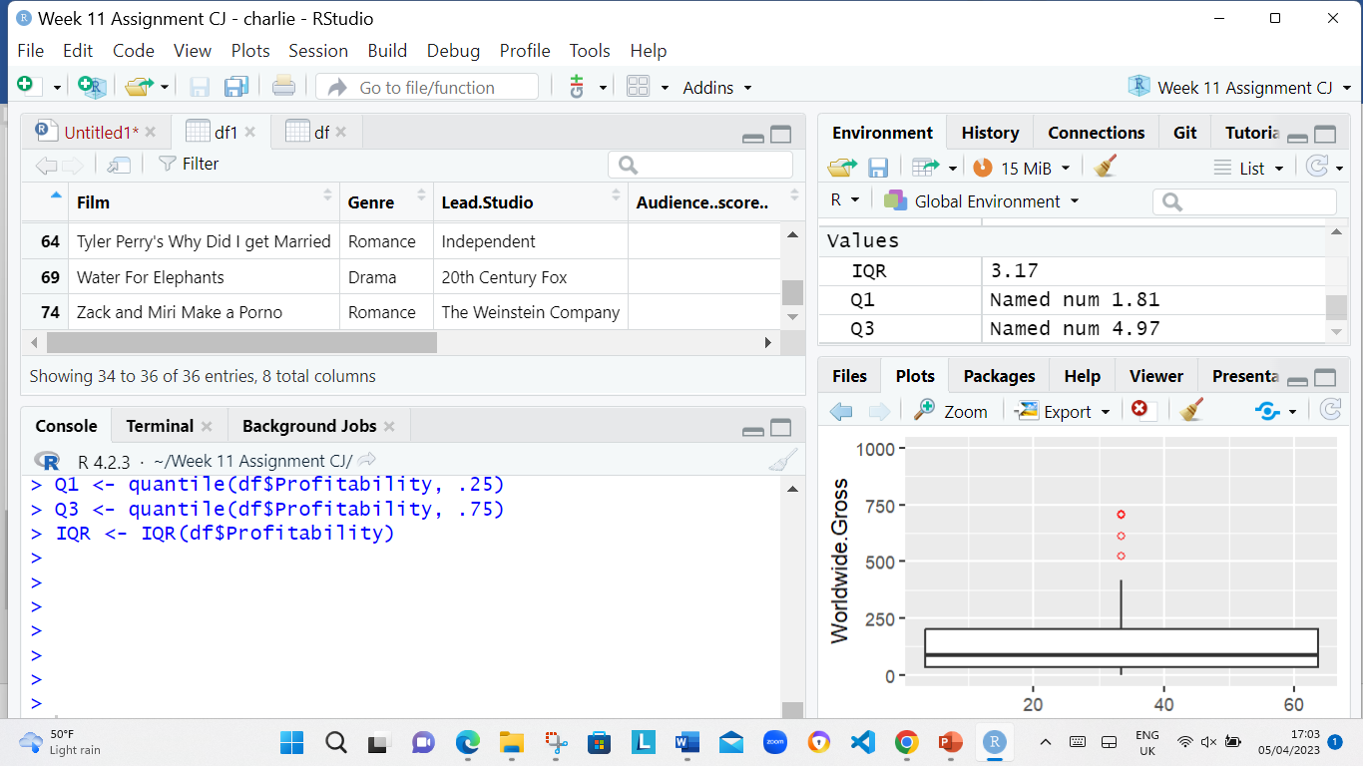

4. The following codes was used to: no_outliers <- subset(df, df$Profitability> (Q1 - 1.5*IQR) & df$Profitability< (Q3 + 1.5*IQR))

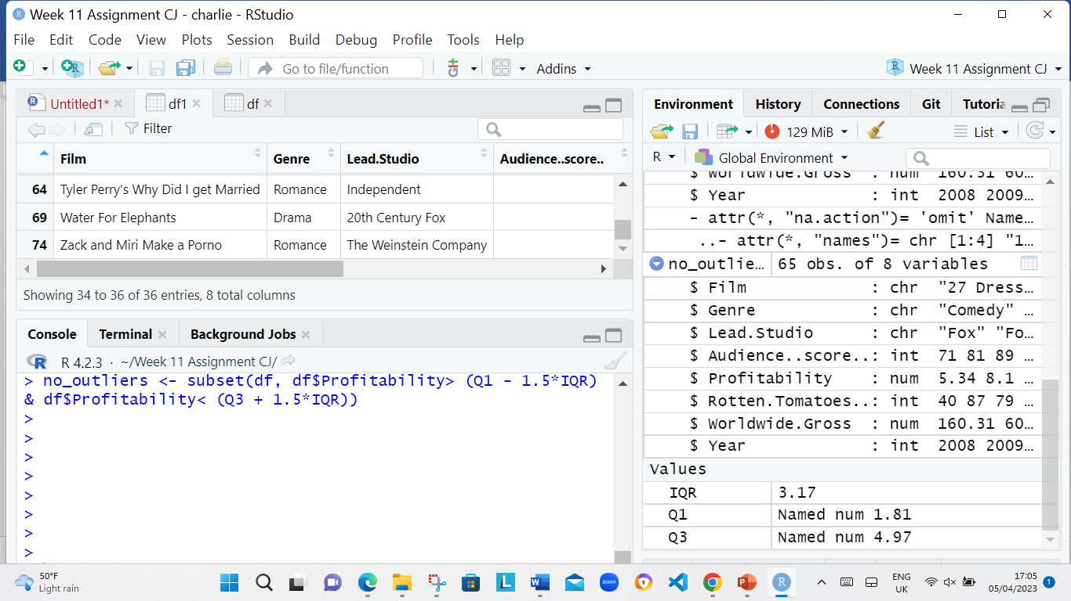

1. The following codes was used dim(no_outliers)

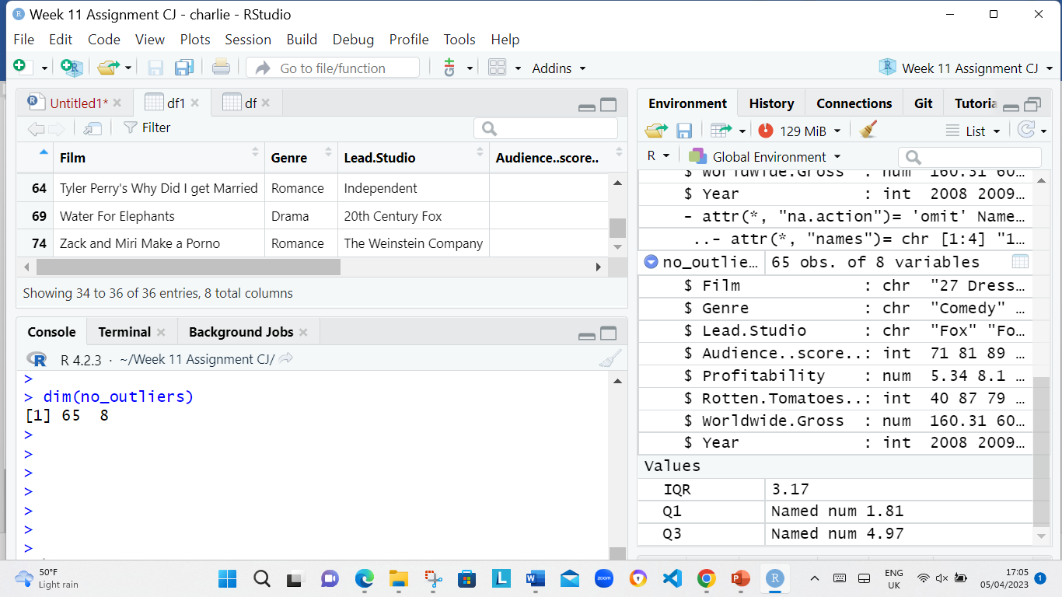

1. The following codes was used to Remove outliers in 'Worldwide.Gross'

Q1 <- quantile(no_outliers$Worldwide.Gross, .25)

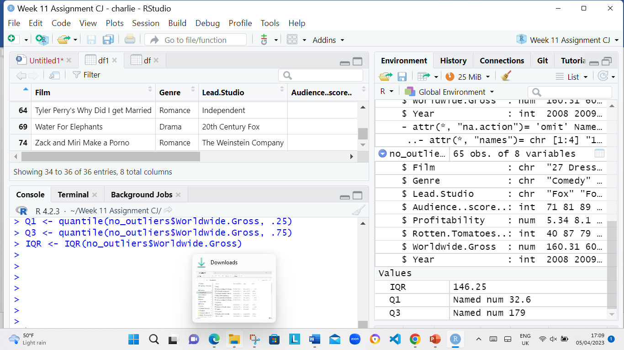

Q3 <- quantile(no_outliers$Worldwide.Gross, .75)



IQR <- IQR(no_outliers$Worldwide.Gross)

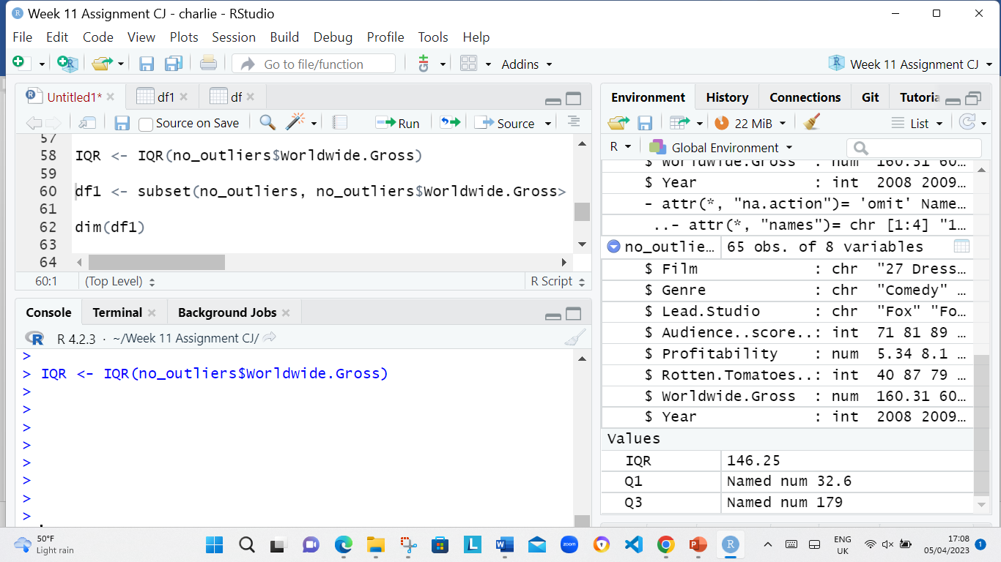

The following codes was used: df1 <- subset(no_outliers, no_outliers$Worldwide.Gross> (Q1 - 1.5*IQR) & no_outliers$Worldwide.Gross< (Q3 + 1.5*IQR))

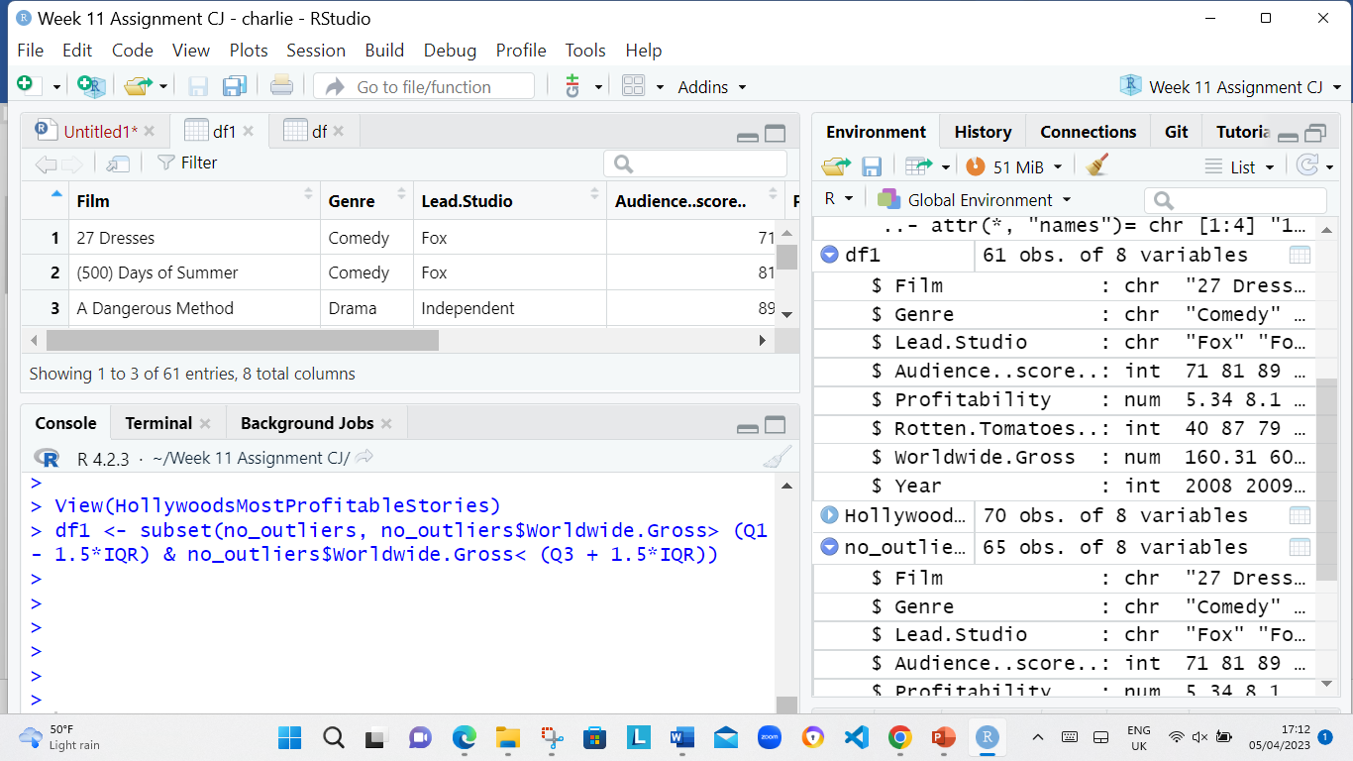

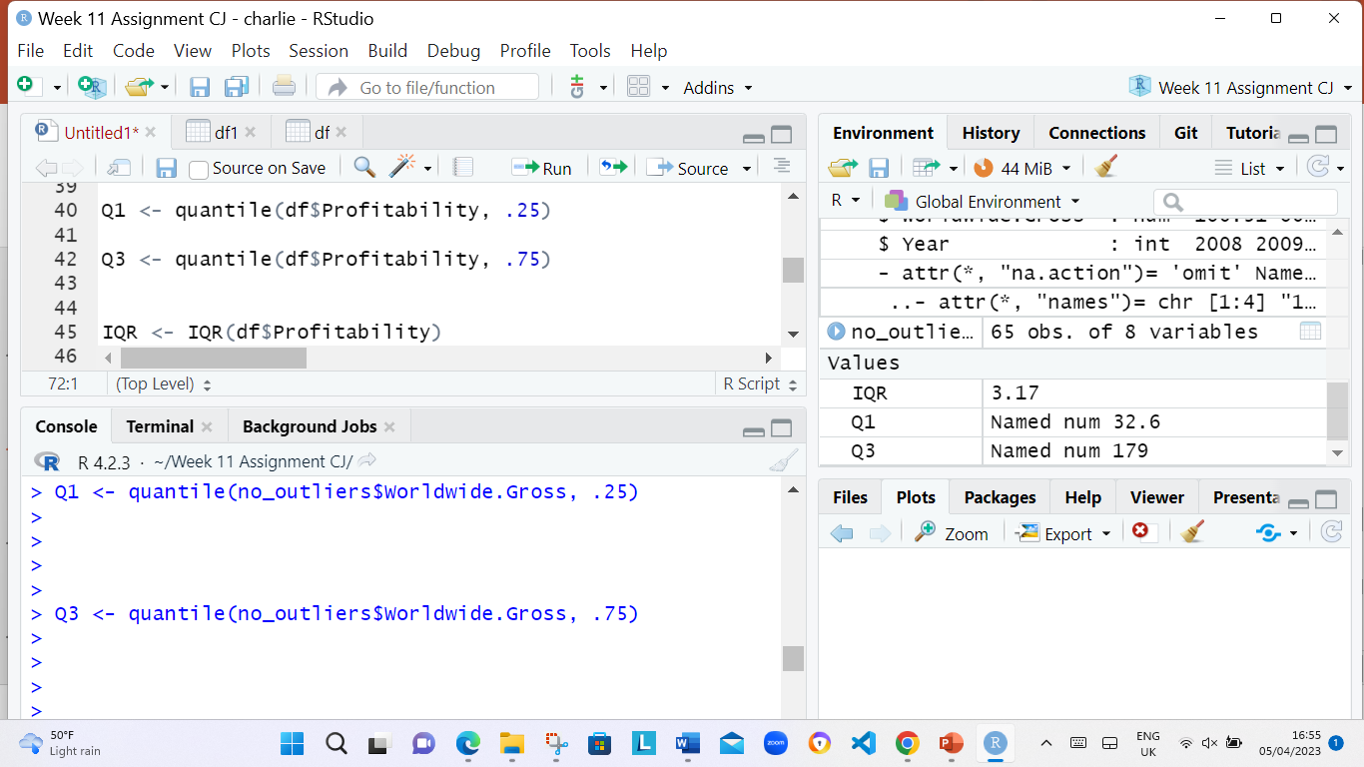

The following codes was used dim(df1)

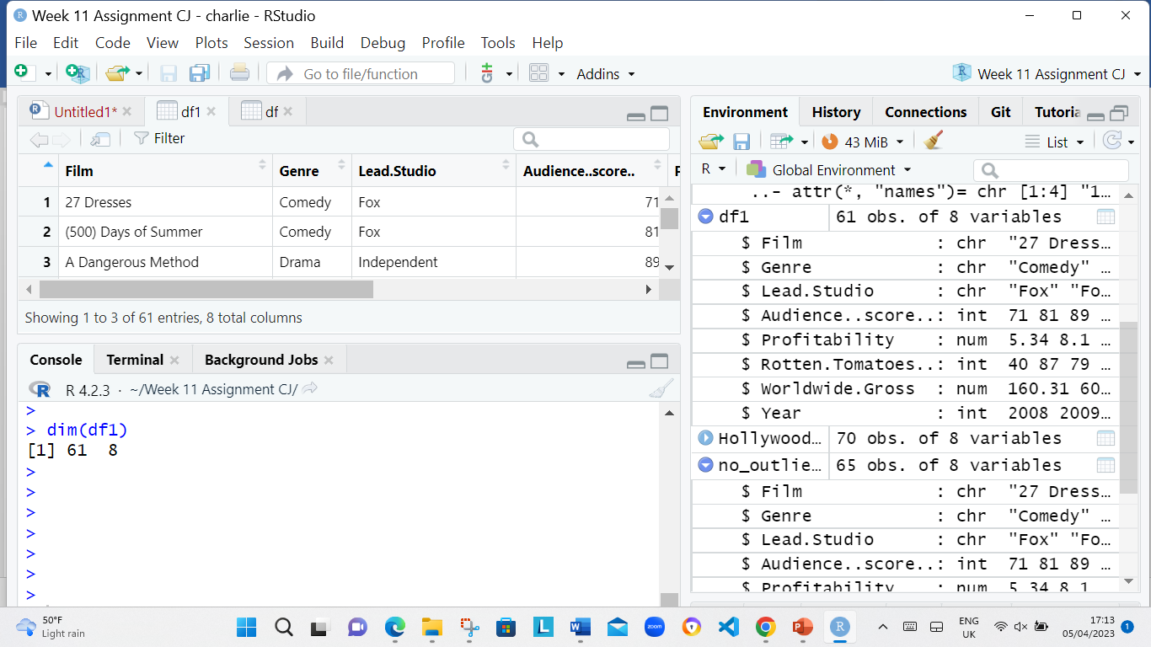

**Step 3: Exploratory Data Analysis**

1. The following codes was used to Summary Statistics/Univariate Analysis:

summary(df1)

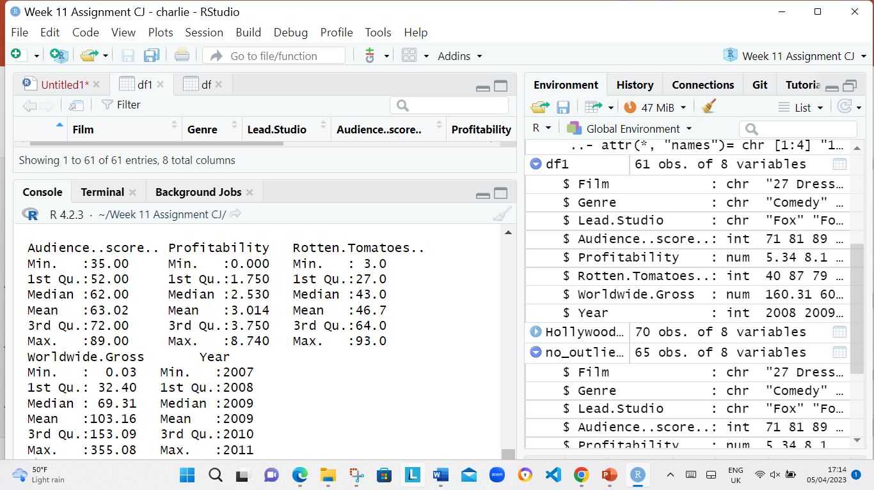

2. The following codes was used to scatterplot:

ggplot(df1, aes(x=Lead.Studio, y=Rotten.Tomatoes..)) + geom_point()+ scale_y_continuous(labels = scales::comma)+coord_cartesian(ylim = c(0, 110))+theme(axis.text.x = element_text(angle = 90))

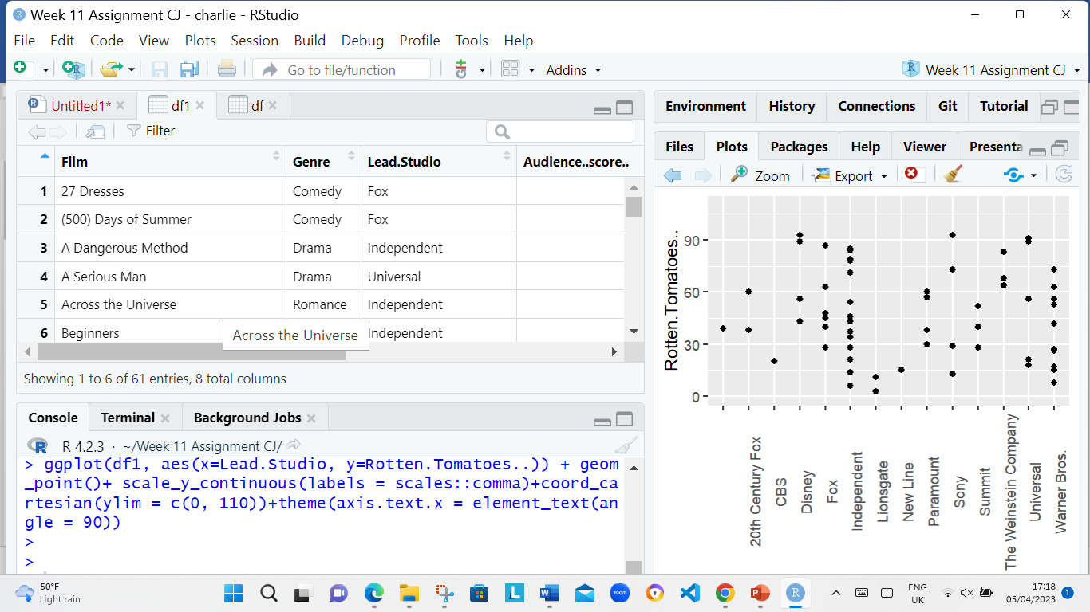

 The following codes was used bar chart:

ggplot(df1, aes(x=Year)) + geom_point()

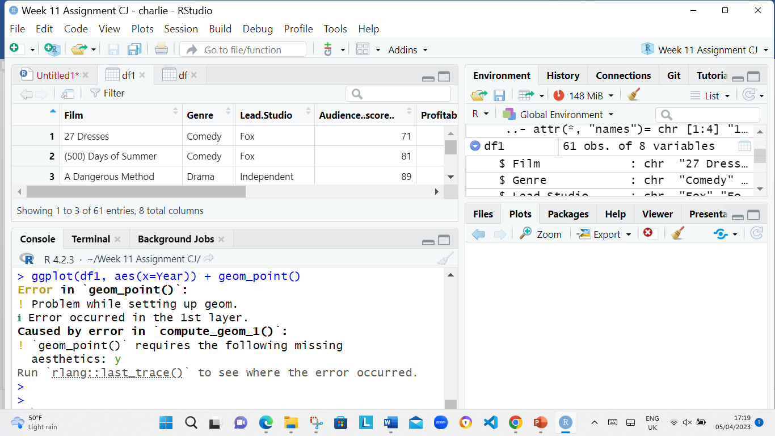

**Step 4: Export data**

1. The following codes was used Export clean data:

write.csv(df1, “clean_df.csv")

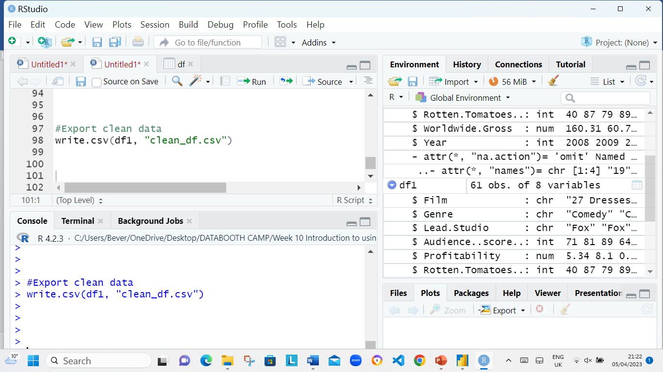

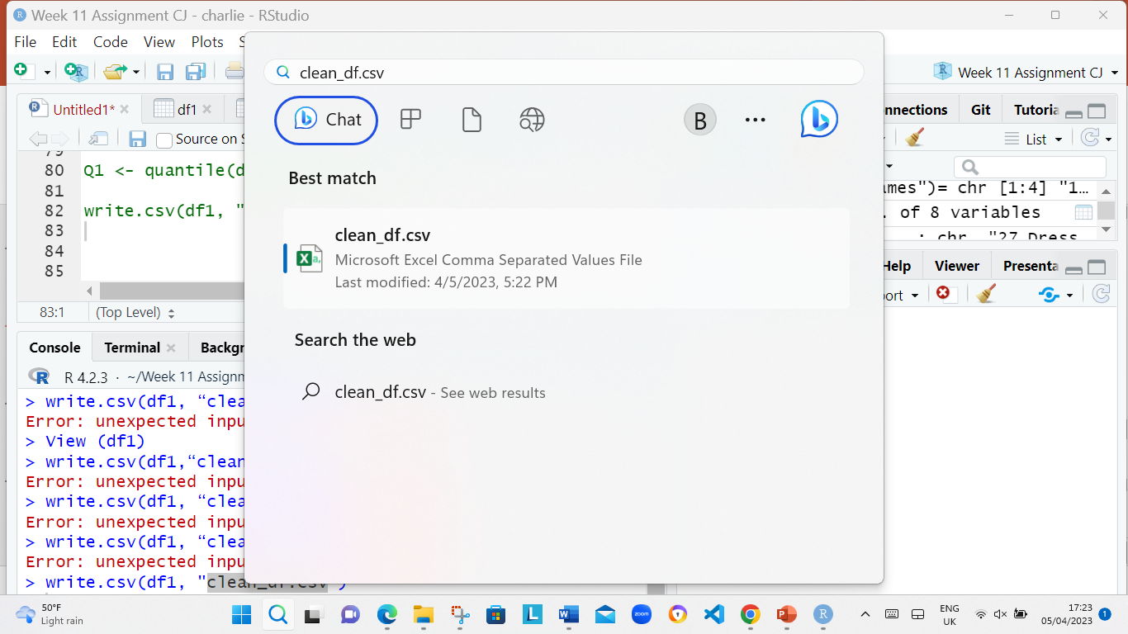

Power B1

1. IMPORT clean_df.csv file into power B1

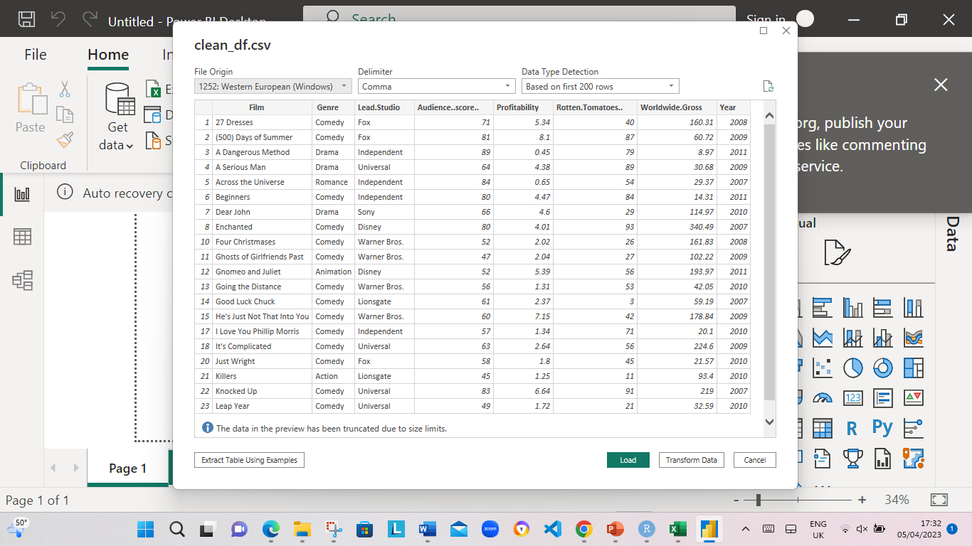

1. Transform data selected to view data.

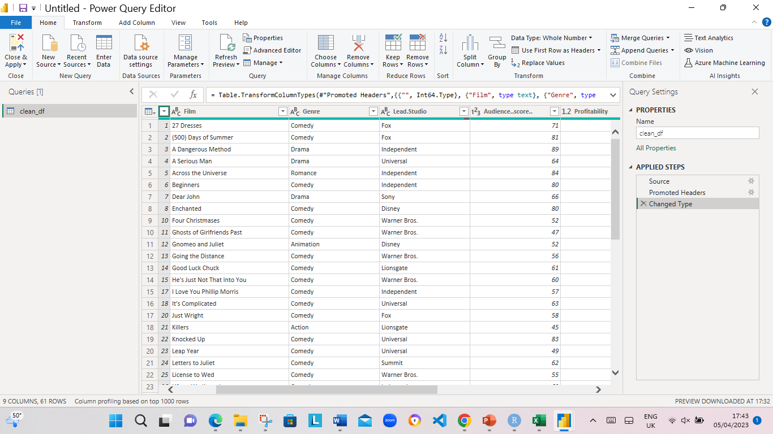

1. Power BI Dashboard that displays the following information listed below:

* The average Rotten Tomatoes ratings of each genre
* The number of movies produced per year
* The audience scores for each film
* The profitability per studio
* The worldwide gross per genre

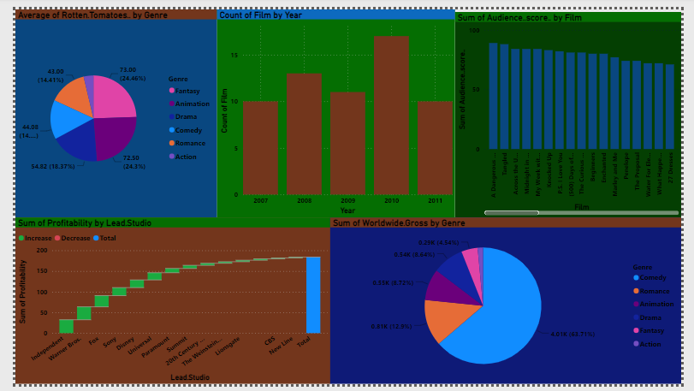

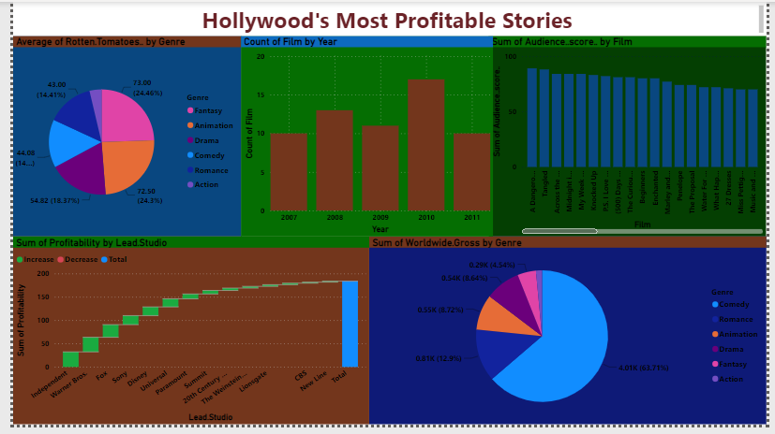

End of Assignment

**Step 4End e: Export data**